7-1 List of System Entities

Product: Project R

Team: 13

Date: 02/27/2018

|  |  |  |
| --- | --- | --- |
| **Type** | **Name** | **Description or Notes** |
| Files Tables | Game Stats | Lists files used to implement character stats, speed, item drops, etc. |
| Code Function | Tutorial | On the first level, check for player’s actions and display a check symbol when the player follows tutorial. |
| Screen | In Game Screen | The screen displayed during standard play. |
| Screen | Pause Screen | Screen displays “return to game”, ”options”, and “quit” buttons while paused |

7-2 Template for Detailed Design for a Screen

**Name**: In Game Screen

**Type**: Screen

**Purpose**: This screen is needed to meet requirement that the player is displayed his character as well as his surroundings.

**Description**: The figure below shows the layout for this screen. This screen will display the player’s character, the information for the character, and the character’s surroundings.

The screen contains the following elements:

1: The player’s character shows the location that the character is on as well as what equipment they have on.

2: The information of the character displays information such as health, mana, and inventory.

3: The character’s surroundings will involve things like enemies, terrain, or npcs.

|  |
| --- |
| 2 |
|  |

7-2 Template for Detailed Design for a Screen

**Name**: Pause Screen

**Type**: Screen

**Purpose**: This screen is needed to meet requirement that the player is displayed his character as well as his surroundings.

**Description**: The figure below shows the layout for this screen. This screen will display the player’s character, the information for the character, and the character’s surroundings.

This screen contains a simple UI for a pause menu that has three options: Return to the Game which simply brings the player back to the game screen, settings which allows the user to alter settings, and quit game which exits the program

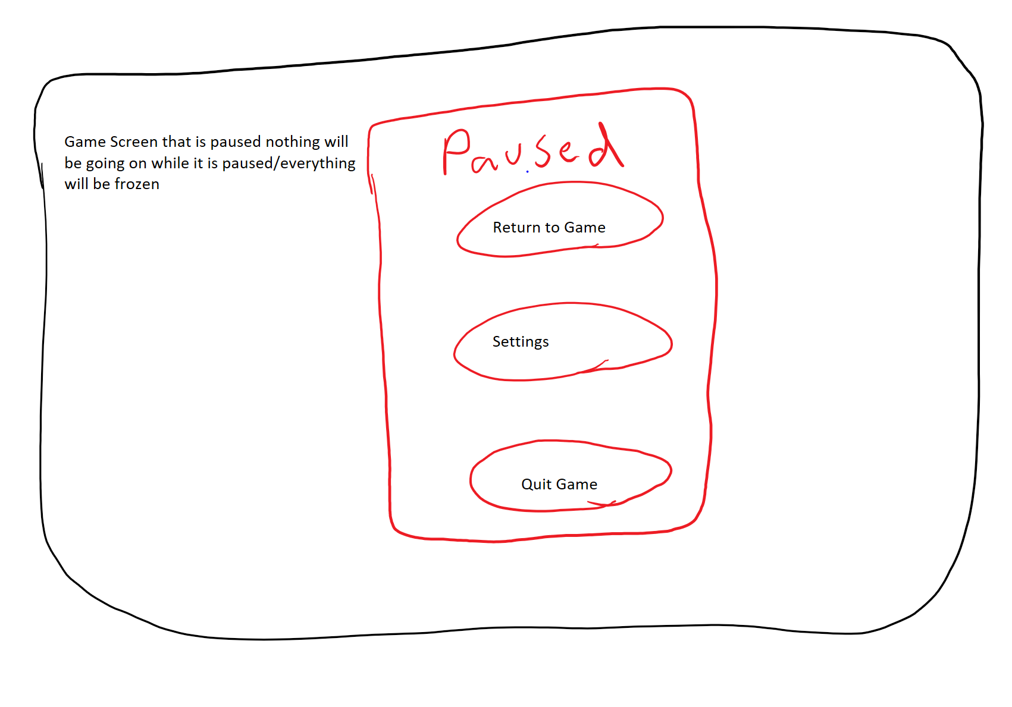

7-3 Template for Detailed Design for a Files Table

**Name**: File List

**Type**: Files Table

**Purpose**: This table is needed to meet requirement 3.1.005, 3.1.006, 3.1.008, 3.1.010

**Description**: Figure <3> lists all the files used for the game, including elements and assets for the project. Each row shows a file element and its description.

**Table Contents:**

|  |  |
| --- | --- |
| **File Element Name** | **Notes** |
| Currency | Currency number for the player to use; The amount of currency available for the player to use |
| Character Stats | Health bar/health points, mana bar/points, current number of items, pictures |
| Enemy Stats | Number of remaining hits, pictures |
| Augmentation | Chances, random number generator for random “enchantment”, Types of “Enchantments” |
| Speed | Movement speed of character, enemies, obstacles, etc. |
| Location | Player starts game at centerstage, enemies and NPCs start at same location (if the game is reloaded) at the start of the game, map data |
| Items | Number of items the character is able to carry; the number of item drops a defeated enemy drops, item pictures |

Figure <3>

7-4 Template for Detailed Design for a Code Function

**Name**: Tutorial

**Type**: Function

**Purpose**: This function is needed to meet requirement 3.1.002

**Parameters**: The following parameters are used to call this function:

|  |  |  |
| --- | --- | --- |
| **Name** | **Data Type** | **Notes** |
| level | integer | Function executes only on the first level (level == 1) |
| checkKeydown1 | boolean | Checks if the user presses key 1 |
| checkKeydown2 | boolean | Checks if the user presses key 2 |

**Return Type**: None

**Processing:**

1. Check if the player is in the first level
2. Display “A, D” and “←, →” to teach users how to move left and right
3. Loop until checkKeydown1 and checkKeydown2 is True
   1. On keydown A or ←
      1. checkKeydown1 is True
   2. On keydown B or →
      1. checkKeydown2 is True
4. Display check mark
5. Reset checkKeydown1 and checkKeydown2 to False
6. Display “Spacebar” to teach users how to jump
7. Loop until checkKeydown1 is True
   1. On keydown Spacebar
      1. checkKeydown1 is True
8. Display check mark
9. Reset checkKeydown1 and checkKeydown2 to False
10. Display “Spacebar” “Spacebar” to teach users how to double jump
11. Loop until checkKeydown1 is True and checkKeydown2 is True
    1. While checkKeydown1 is True
       1. If Spacebar is pressed
          1. checkKeydown2 is True
          2. Break loop
    2. Else
       1. checkKeydown2 is False
    3. On keydown Spacebar
       1. checkKeydown1 is True
       2. When jump animation ends, set checkKeydown1 to False
12. Display check mark
13. [Incomplete code function since we don’t know what other keys we may use] Additional functions needed: combat tutorial

7-5 Team Capability Assessment

|  |  |  |  |  |
| --- | --- | --- | --- | --- |
|  | Min | Scott | Peter | Ryan |
| Unity | 2 | 3 | 2 | 2 |
| Pixel Art | 2.5 | 2 | 1 | 1 |
| Music | 1 | 1 | 1 | 1 |
| Design | 2 | 2 | 2 | 2 |
| File managing | 3 | 2 | 2 | 2 |
| Communication | 3 | 3 | 2 | 2 |